
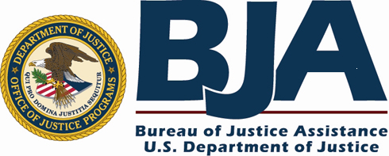

The software was donated by Judge Thomas Amodeo, Chief Judge, Judge Robert Russell, Drug Court Judge, Hank Pirowski and Jose Ferrer of the Court Administration staff of the Buffalo City Court to the BJA Drug Court Technical Assistance Project at American University for distribution to other drug courts and veterans courts to adapt for use in their respective drug court and veterans court program.

The Buffalo DMIS-2010 is a simple, menu-driven system, operating on Microsoft Access. On-screen forms mimic those typically used to record information on drug court clients from intake through to their termination or graduation. The DMIS contains built-in reports to summarize and print case file information. Four individual progress reports can be produced. The Case Summary Report presents information on a participant’s current status, outcomes and progress at each drug court date, and total progress to date. The other three individual reports summarize a participant’s 12-Step Progress, Urinalysis Results, and Payments.

Some of the features of this MIS system are:
- Ability to quickly store and retrieve information about the drug court participants, including mental health conditions
- Adds and calculates any data to produce statistical reports
- The ability to create visual reports (Charts and Graphs)
- The ability to sort the data by variables, (e.g., return court date, last name, age and any other field that has been set to a text, date, currency or number)
- Allows the user(s) to print hard copies of participant’s records
- Allows the user to document a participant’s treatment history, type of services received, entry date, and discharge date. Additionally the program will automatically calculate the length of stay in days.

Jose Ferrer of the Buffalo Drug Court is currently updating the software as well as incorporating a web access feature to allow for web based interface with treatment providers and other agencies involved with the program to record information about the client. Drug Court and Veterans Court programs using these feature will need to have enhanced software and web access capabilities.

System Requirements
The user must have installed Microsoft Access 2000 or 2003 before running DMIS-2010 Data Management System.

Contact Information
For further information regarding the Buffalo DMIS 2010, please contact:

Bureau of Justice Assistance Drug Court Technical Assistance Project
Justice Programs Office, School of Public Affairs
American University
4400 Massachusetts Avenue N.W., Brandywine Suite 100
Washington D.C. 20016-8159
Tel: 202/885-2875 Fax: 202/885-2885
Email: justice@american.edu Website: www.american.edu/justice

