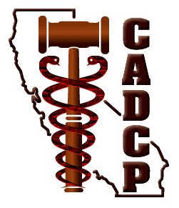
California Association of Drug Court Professionals
www.cadcp.org

ONE DAY TRAINING
Trauma–Informed Responses:
The Missing Piece for Effective Treatment Courts

REGISTRATION
Faculty, Staff or Pre-Approved

Date: |  |  | County:
Name: |  |  | E-mail:
Court/Organization/Agency:
Address:
Address Line 2: |  |  |  | City:
State |  | Zip Code: |  | Country:

You are a:
Judge |  | Coordinator |  | Probation |  | Treatment
Prosecutor |  | Defense |  | Other(specify)

Are you a paid 2013 CADCP Member? | Yes | No

Please indicate if ADA assistance is required. | Yes | No

Lunch and refreshments are included in your registration fee.
Please indicate:
No Diet Restriction |  | Vegetarian |  | Vegan |  | Gluten-Free

Please select which Facilitated Breakout by Target Population you plan to attend:

Adult Males |  | Adult Females |  | Veterans |  | Mentally Ill |  | Children & Youth

Have questions? Call 510-347-4444

Mail your completed registration form and payment to:

CADCP
P.O. Box 1055
San Leandro, CA 94577-0121

